**Orchestrate Scheduling Interface Requirements**

**Version 1.3**

**Prepared By: Rich Allison**

**Date: 8/2/2019**

Document Control 3

Resources 3

Project Distribution List 3

Document Version Control 3

1. Introduction 4

1.1 Purpose 4

1.2 Project Scope 4

1.3 Terminology Standards 4

1.3.1 Acronyms 4

1.3.2 Glossary 4

1.4 Document References 4

*2.* Diagram 5

3. Requirements 6

3.1 Functional Requirements 6

3.2 Non-Functional Requirements 7

4. HL7 Messaging 7

4.1 Messaging Format 7

4.1.1 Segments 7

4.1*.*3 Cloverleaf Configuration Files 8

4.1.4 Cloverleaf Site Location 8

4.2 Data Transformation Requirements 9

4.3 Sample Message 12

5. Testing 13

5.1 Piloting 13

5.2 Approvals 13

Appendix A: Risks and Concerns 14

Appendix B: Issues List 14

# **Document Control**

## Resources

|  |  |  |
| --- | --- | --- |
| **Name** | **Role** | **Email** |
| Nydia Anders | IS Project Manager | Nydia.anders@baycare.org |
| Rich Allison | Enterprise Integration Analyst, Sr | Rich.allison@baycare.org |
| Rod Stephens | Teletracking Systems Analyst | Rod.stephens@baycare.org |
| Terri Norton | Teletracking Systems Analyst Sr. | Terri.norton@baycare.org |
| Tony McArtor | Enterprise Integration Analyst, Sr | Tony.mcartor@baycare.org |
| Donald Golden | IS Manager Clinical Systems | Donald.golden@baycare.org |
| Kim Bell | IS Supervisor Clinical Systems | Kim.bell@baycare.org |
| Amelia Malick | Teletracking Vendor | Amelia-malick@teletracking.com |
| Nate Gilkerson | Teletracking Vendor | Nate-gilkerson@teletracking.com |
| Andrew Skvarca | Teletracking Vendor | Andrew-skvarca@teletracking.com |

## Project Distribution List

## Document Version Control

|  |  |  |  |
| --- | --- | --- | --- |
| **Version** | **Date** | **Modifier** | **Description** |
| V1.0 | 6/13/2016 | Lois Whitley | Originally Created |
| V1.1 | 6/28/2016 | Rich Allison | Added Cloverleaf info |
| V1.2 | 3/2/2017 | Rich Allison | Updated document |
| V1.3 | 8/2/2019 | Tiffany Bohall | Updated to reflect production build |
|  |  |  |  |

# 1. Introduction

## 1.1 Purpose

The purpose of this document is to outline the Scheduling interface requirements for the Orchestrate Teletrack application.

## 1.2 Project Scope

Integration for this application includes a Scheduling interface (SIU) from Soarian to Orchestrate, Orders Interface (ORM) from Cerner and an Orders interface from the RIS to Orchestrate. The project includes only certain modalities, please see additional details below to determine the latest being sent. There are two sources of patient information: Soarian Scheduling for outpatients and Cerner Orders for Inpatients and Emergency Room Visits.

## 1.3 Terminology Standards

### 1.3.1 Acronyms

**SIU –** Scheduling Information Unsolicited; notifies an auxiliary application of changes to some facet of the filler application's appointment schedule.

### 1.3.2 Glossary

**TeleTracking** is the vendor name.

**Orchestrate** is the application.

## 1.4 Document References

Orchestrate HL7 Interface Specifications

# *2.* Diagram

Provide a solution diagram that depicts the integration of components specified in this IDBB. This diagram must include the data flow for the interfaces (source and target).

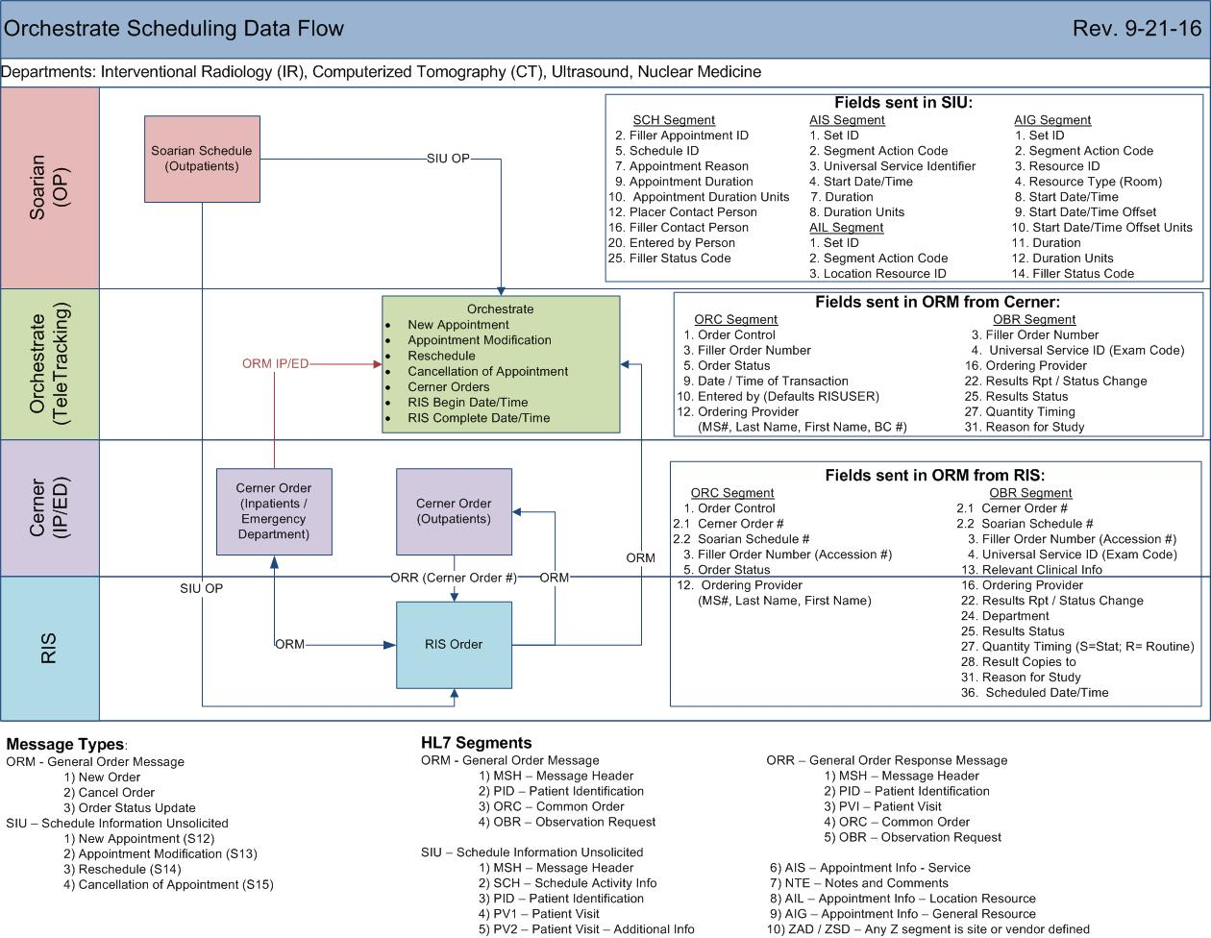

# 3. Requirements

## 3.1 Functional Requirements

Provide detail for the below functional requirements. The message transformation requirements for the components defined in this specification should be specified in section 4.2 of this document.

|  |  |  |
| --- | --- | --- |
| **Cloverleaf** |  |  |
| **Number** | **Requirement Name** | **Requirement Description** |
| FR.2019.8.2.1 | TpsAdvHL7Filter **on route 1:**  -pass certain modalities  -suppress certain locations  TpsAdvHL7Filter on **route 2:**  TpsAdvHL7Filter on **route 3:** | Only these modalities are being passed based on HL7 field ZAD.2.0:  NM –Nuclear Medicine  IP – NOT VALID  US -Ultrasound  CT –Cat Scan  MR -MRI  BN - NOT VALID  SP -Specials  WM -Mammo  BD -Dexa  CDH –Children’s Day Hospital  EC -Echo  DX -Diagnostic  PET –Pet Scan  If MSH.3 = UBJ5 (BayCare Life Management), HBJ5 (Winter Haven CBD), SBJ5 (SIP), IBJ5 (ISU), CBJ5 (CRC) or BBJ5 (BayCare Behavioral Health outpatient services) suppress  Only these modalities are being passed based on HL7 field ZAD.2.0:  PT –Physical Therapy  OT –Occupational Therapy  ST –Speech Therapy  AUD -Audiology  PPT - Pediatric Physical Therapy  POT - Pediatric Occupational Therapy  PST - Pediatric Speech Therapy  PET -Pet Scan  Pass all transactions where PV1.39 =BCBH or PCBLOOM |
| FR.2019.8.2.2 | Xlate: soars_teletrac_orch_siu.xlt | See customer facing document. The AIS, AIL and AIG scheduling segments and Note segments are PATHCOPY’d to send all data in those segments. |

## 3.2 Non-Functional Requirements

Provide concise detail for the below non-functional requirements. The below requirements must be evaluated for every project.

|  |  |  |
| --- | --- | --- |
| **Cloverleaf** |  |  |
| **Number** | **Requirement Name** | **Requirement Description** |
| NFR.20XX.1.0 | Click here to enter text. | Click here to enter text. |

# 4. HL7 Messaging

## 4.1 Messaging Format

Inbound: HL7 2.6 Soarian SIU_S12

Outbound: HL7 2.6 Soarian SIU_S12

### 4.1.1 Segments

The segments utilized for this interface are:

MSH

SCH

PID

[PV1]

AIS

[{NTE}]

[ZOR]

[ZAD]

*Message Construction Notes:*

*[Square Brackets] – Optional*

*{Curly Brackets} – Repeatable*

*MSH – Message Header*

*SCH – Schedule Activity Info Segment*

*PID – Patient ID segment*

*PV1 – Patient Visit segment*

*AIS – Appointment Info – Service Segment*

*NTE – Notes and Comments Segment*

*ZOR – No valid segment definition since custom built*

*ZAD/ZSD – Any Z segment is site or vendor defined*

**4.1*.*2 Messaging Event Types**

Below are the messages types necessary for this integration being passed on all routes from Cloverleaf to Orchestrate

|  |  |
| --- | --- |
| **Event Type** | **Description** |
| S12 | New Appointment |
| S13 | Appointment Modification |
| S14 | Reschedule |
| S15 | Cancellation of Appointment |

### 4.1*.*3 Cloverleaf Configuration Files

For each HL7 interface specified in Section 2 of this document, identify the Cloverleaf Configuration Files: Variants, TCL Scripts, Xlates, etc.

Variants:

HL7 2.6/Soarian SIU_12

Xlates:

soars_teletrac_orch_siu.xlt

Filters:

Are document in functional requirements section 3.1 via tpsAdvHL7Filter.

Tables:

Soarf_facility_codes.tbl used for MSH.4 cross walking in xlate

### 4.1.4 Cloverleaf Site Location

Soarian schedules come in on the soars_siu_29 site. There is a transfer connection sending all schedules destined for Orchestrate over to the teletrck_24 site where message filter and manipulation takes place.

## 

## 4.2 Data Transformation Requirements

| **Field Description** | **HL7 Field Loc.** | **Required Y/N** | **Data Type** | **Length** | **Notes** |
| --- | --- | --- | --- | --- | --- |
| Message Header | varies |  |  |  | Pathcopy entire MSH segment |
| Message Segment Field Separator | MSH.1 |  |  |  | Hard code | |
| Encoding Characters | MSH.2 |  |  |  | Hard code ^~\& |
| Sending Facility | MSH.4 |  |  |  | Convert the Soarian facility to the standard 3 character facility using the soarf_facility_codes.tbl |
| Receiving Application | MSH.5 |  |  |  | Hard coding Orchestrate |
| Receiving Facility | MSH.6 |  |  |  | Copy facility from the output of MSH.4 |
| Placer Appointment ID | SCH.1 |  |  |  | Copy from SCH.2 |
| Schedule ID | SCH.5 |  |  |  | Copy  Used in Orchestrate as procedure description:  i.e SCHEDNEW_ACK |
| Appointment Reason | SCH.7 |  |  |  | Procedure Description |
| Appointment Duration | SCH.9 |  |  |  | Copy |
| Appointment Duration Units | SCH.10 |  |  |  | Copy |
| Appointment Timing Quantity | SCH.11 |  |  |  | Copy |
| Placer Contact Person | SCH.12 |  |  |  | Copy |
| Filler Contact Person | SCH.16 |  |  |  | Copy |
| Entered by Person | SCH.20 |  |  |  | Copy |
| Filler Status Code | SCH.25 |  |  |  | Copy |
| Patient ID | PID.2 |  |  |  | Iterate on PID.3.4 to find MR or MRN, copy PID.3 outbound if found |
| Patient Identifier List | PID.3 |  |  |  | Iterate on PID.3.3 to find 900000, copy PID.3 outbound with TCL proc that pads CPI number with 0’s if length is less than 9. |
| Patient Name: Family Name, Given Name, Second and Further Given and Suffix | PID.5.0  PID.5.1  PID.5.2  PID.5.3 |  |  |  | Copy |
| Birth Date | PID.7 |  |  |  | Copy |
| Gender | PID.8 |  |  |  | Copy |
| Patient Address: Street Address, Other designation, City, State, Zip code | PID.11.0  PID.11.1  PID.11.2  PID.11.3  PID.11.4 |  |  |  | Copy |
| Primary Language | PID.15 |  |  |  | Copy |
| Patient Account Number | PID.18 |  |  |  | Copy  Used in Orchestrate to uniquely identify a patient internally |
| Patient Class | PV1.2 |  |  |  | Copy |
| Attending Doctor: ID, Family Name, Given Name, Second and Further Given, Suffix | PV1.7.0  PV1.7.1  PV1.7.2  PV1.7.3  PV1.7.4 |  |  |  | Copy |
| Hospital Service | PV1.10 |  |  |  | Copy |
| Admitting Doctor: ID, Family Name, Given Name, Second and Further Given, Suffix | PV1.17.0  PV1.17.1  PV1.17.2  PV1.17.3  PV1.17.4 |  |  |  | Copy |
| Patient Type | PV1.18 |  |  |  | Copy |
| Servicing Facility | PV1.39 |  |  |  | Copy |
| Admit Date / Time | PV1.44 |  |  |  | Copy |
| Discharge Date/Time | PV1.45 |  |  |  | Copy if PV1.45 does not equal NULL |
| Appointment Info Segment - Service | Varies |  |  |  | Iterate on group 1 and path copy entire AIS segment outbound |
| Notes and Comments segment 1 | Varies |  |  |  | Iterate on NTE group 1 and path copy entire NTE segment outbound |
| Appointment Info Segment –Location Resource | Varies |  |  |  | Iterate on group 2 and path copy entire AIL segment outbound |
| Notes and Comments segment 2 | Varies |  |  |  | Iterate on NTE group 2 and path copy entire NTE segment outbound |
| Appointment Info Segment –  General Resource | Varies |  |  |  | Iterate on group 3 and path copy entire AIG segment outbound |
| Notes and Comments segment 3 | Varies |  |  |  | Iterate on NTE group 3 and path copy entire NTE segment outbound |
| Site Defined Segment | ZAD |  |  |  | path copy entire ZAD segment outbound |
| Site Defined Segment | ZSD |  |  |  | path copy entire ZSD segment outbound |

## 4.3 Sample Message

**Inbound from Soarian to Cloverleaf**

MSH|^~\&|SOARIAN^SCHEDULING|M0J5|CLOVERLF|M0J5|201908020654||SIU^S12||P|2.4

SCH||5901493|||SCHEDNEW_ACK||^test||15|MIN||068336^BEACH^CAITLIN||||^Shaw, Kyle^^001030||||^Shaw, Kyle^^001030|||||""^^^""

PID|1||5400058049^^^^PN^~7000109672^^^504^MR^^^^^~810120220^^^900000^PI^^^^^||NUANCE^PS360^^""^""^""||19750118|M|""||""^""^""^""^""^""^^""||^H||""|||6000145117^^^^VCD

PV1||O|||||068336^BEACH^CAITLIN|000000^UNKNOWN^DOCTOR||CAT|||||||068336^BEACH^CAITLIN|A|5400058049^^^^PN^^^^^||||||||||||||||||||BOI Bardmoor|||||201908020900

PV2|||||||||||||||||||||||BOI Bardmoor

AIS|1|A|CAB^CT Abd wo Con|201908020900|||15|MIN

NTE|1||""|REFAUTH

NTE|1||Caller's Name:^test^sch_user_30char_01|QA

NTE|1||Script Delivery^FAX^sch_user_60char_03|QA

NTE|1||Does patient have any special needs?^N^sch_user_01char_01|QA

NTE|1||Order Priority^""^PRIORITY|QA

AIL|1|A|BIC^^^^^^^^BOI Bardmoor

AIG|1|A|BICT1^BIC CT Room 1|ROOM||||201908020900|0|MIN|15|MIN||BOOKED

ZAD||CT^CT Scan|||""|0

ZSD|769.7415001^^L^74150^^C4^^^^BCT0007^^L

**Outbound from Cloverleaf to Orchestrate**

MSH|^~\&|SOARIAN^SCHEDULING|BOI|Orchestrate|BOI|201908020654||SIU^S12||P|2.4

SCH|5901493||||SCHEDNEW_ACK||^test||15|MIN||068336^BEACH^CAITLIN||||^Shaw, Kyle^^001030||||^Shaw, Kyle^^001030|||||""^^^""

PID||7000109672|810120220||NUANCE^PS360^^""||19750118|M|||""^""^""^""^""||||""|||6000145117

PV1||O|||||068336^BEACH^CAITLIN|||CAT|||||||068336^BEACH^CAITLIN|A|||||||||||||||||||||BOI Bardmoor|||||201908020900

AIS|1|A|CAB^CT Abd wo Con|201908020900|||15|MIN

NTE|1||""|REFAUTH

NTE|1||Caller's Name:^test^sch_user_30char_01|QA

NTE|1||Script Delivery^FAX^sch_user_60char_03|QA

NTE|1||Does patient have any special needs?^N^sch_user_01char_01|QA

NTE|1||Order Priority^""^PRIORITY|QA

AIL|1|A|BIC^^^^^^^^BOI Bardmoor

AIG|1|A|BICT1^BIC CT Room 1|ROOM||||201908020900|0|MIN|15|MIN||BOOKED

ZAD||CT^CT Scan

# 5. Testing

## 5.1 Piloting

List the facilities and associated networks in scope for pilot testing.

## 5.2 Approvals

|  |  |  |  |
| --- | --- | --- | --- |
| **Testing Phase** | **Date** | **Department** | **Team Member** |
| PH1.0 |  |  |  |
|  |  |  |  |
|  |  |  |  |

# Appendix A: Risks and Concerns

|  |  |  |  |  |  |  |  |  |
| --- | --- | --- | --- | --- | --- | --- | --- | --- |
| **Project Name** |  |  | | |  |  |  |  |
| **Number** | **Risk / Concern** | **Comment** | **Mitigation** | | |  |  |  |
| RC.2013.1.0 |  |  | |  | |  |  |  |

# Appendix B: Issues List

This is a dynamic list of the open issues related to the IDBB that remain to be solved, including but not limited to TBDs, pending decisions, information needed, conflict awaiting resolution, and the like.

|  |  |  |  |  |  |  |  |  |
| --- | --- | --- | --- | --- | --- | --- | --- | --- |
| **Project Name** |  |  | | |  |  |  |  |
| **Number** | **Issue** | **Comment** | **Fix** | | |  |  |  |
| I.2013.1.0 |  |  | |  | |  |  |  |

* End of document